

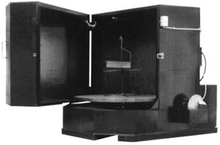

HARRIS TOOL COMPANY MODEL NO. WA-JUMBO-HD
50 X 72 FRONT LOAD SUPER HEAVY DUTY WASHER WITH FOLLOWING MACHINE SPECIFICATIONS:

- TOGGLE SWITCH OPERATED STAINLESS DISC TYPE OIL SKIMMER
- 27 KW ELECTRIC HEATER
- REMOVEABLE TANK DEBRIS SCREEN (330 SQ. IN.)
- 15 HP CAST IRON VERTICAL SEALESS PUMP W/SCREEN(315 GPM @ 55 PSIG)
- 60 MIN.SPRING WOUND WASH TIMER
- 175 DEGREES F PROCESS THERMOSTAT CONTROLLER
- CRANE LOAD SLOT
- FORK LIFT CHANNELS FOR PORTABILITY
- 50 REPLACEABLE/CLEANABLE SPRAY JET NOZZLES
- 300 GALLON CLEANING SOLUTION TANK
- LOW WATER SHUT-OFF SWITCH
- 5,000 LB. LOAD CAPACITY
- 72” INSIDE HEIGHT
- 1/2 HP GEARMOTOR/GEAR DRIVEN 50” DIA. HD TURNTABLE/TRUCK HUB ASSY. & JOG SWITCH
- 240/480/60/3 ELECTRICAL REQUIREMENTS(PLEASE SPECIFY VOLTAGE)
- INTERMEDIATE SPRAY BAR W/ NOZZLES
- ½”PIN/KNUCKLE HINGED SEALESS DOOR W/ HANDLE, LATCH, AND SAFETY SWITCH
- 10 GAUGE TANK/12 GAUGE DOOR & CABINET STEEL PLATE MATERIAL W/ PRECAUTION BLUE PAINT
- 106” OVERALL HEIGHT
- 66”W X 72”D FLOOR SPACE REQUIRED W/ DOOR CLOSED
- 3800 LBS. SHIPPING WT.

